**Experiment: 1**

**Aim:** Create a user define function named ASCII which accept one argument (of character type) and display ASCII value of that character

**Software:** Dev C++

**Code:**

**#include<stdio.h>**

**void ASSCI (char a)**

**{**

**printf("The ASSCI Value of %c Is %d",a,a);**

**}**

**int main()**

**{**

**char a;**

**printf("Enter A Character:-");**

**scanf("%c",&a);**

**ASSCI(a);**

**return 0;**

**}**

**Output:**

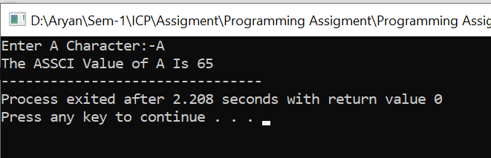

**Experiment: 2**

**Aim:** Write a program that take input names of 10 students. Arrange them in ascending order in string array.

**Software:** Dev C++

**Code:**

**#include<stdio.h>**

**#include<string.h>**

**int main()**

**{**

**char names[10][30],temp[30];**

**printf("Enter 10 names:\n");**

**for(int i=0; i<10;i++)**

**{**

**scanf("%s",&names[i]);**

**}**

**for(int i=0;i<10;i++)**

**{**

**for(int j=i+1;j<10;j++)**

**{**

**if(strcmp(names[i],names[j])>0)**

**{**

**strcpy(temp,names[i]);**

**strcpy(names[i],names[j]);**

**strcpy(names[j],temp);**

**}**

**}**

**}**

**printf("Names in ascending order are:");**

**for(int i=0;i<10;i++)**

**{**

**printf("\n%s",names[i]);**

**}**

**return 0;**

**}**

**Output:**

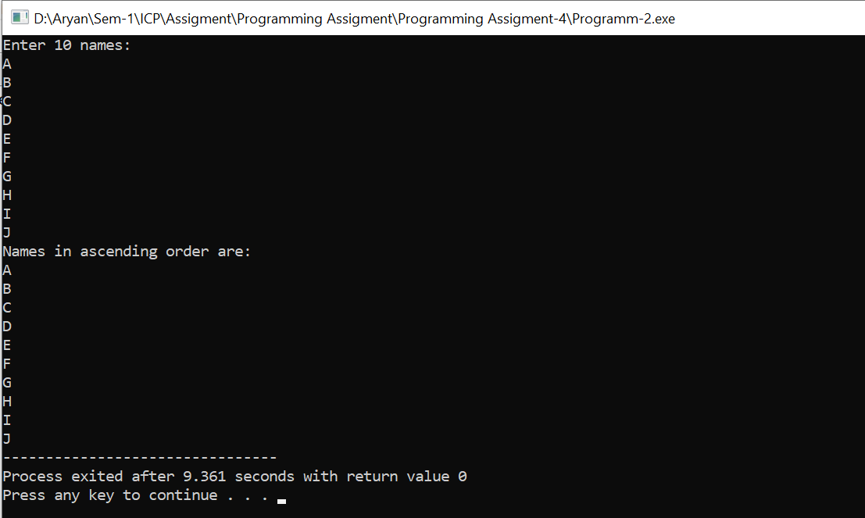

**Experiment: 3**

**Aim:** Write a function that receives five integers and returns the average of these numbers.  
Call this function from main() and print the results in main()

**Software:** Dev C++

**Code:-**

**#include<stdio.h>**

**#include<string.h>**

**double avgn (int a1,int a2,int a3,int a4,int a5)**

**{**

**double avg;**

**avg= (a1+a2+a3+a4+a5)/5;**

**return avg;**

**}**

**int main()**

**{**

**int a[5];**

**float avg;**

**for(int i=0;i<5;i++)**

**{**

**printf("Enter The Element at Index-%d:-",i+1);**

**scanf("%d",&a[i]);**

**}**

**avg=avgn(a[0],a[1],a[2],a[3],a[4]);**

**printf("The Average Is %.2f\n",avg);**

**return 0;**

**}**

**Output:**

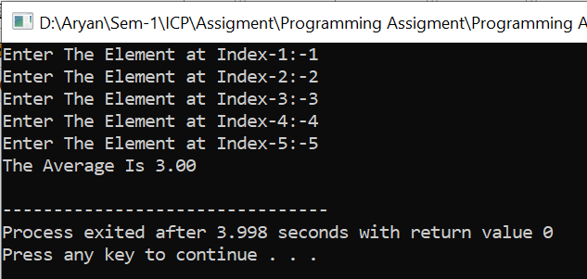

**Experiment: 4**

**Aim:**  Write a C program to obtain the greatest common divisor (GCD) of two integers using  
iterative and recursive methods.

**Software:** Dev C++

**Code:-**

**#include <stdio.h>**

**int hcf(int n1, int n2);**

**int main()**

**{**

**int n1, n2;**

**printf("Enter the First Number:-");**

**scanf("%d", &n1);**

**printf("Enter the Second Number:-");**

**scanf("%d", &n2);**

**printf("G.C.D of %d and %d is %d.", n1, n2, hcf(n1, n2));**

**return 0;**

**}**

**int hcf(int n1, int n2)**

**{**

**if (n2 != 0)**

**{**

**return hcf(n2, n1 % n2);**

**}**

**else**

**{**

**return n1;**

**}**

**}**

**Output:-**

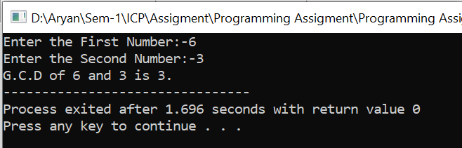

**Experiment: 5**

**Aim:-**  Write a function to generate the square of any given number

**Software:-** Dev C++

**Code:-**

**#include<stdio.h>**

**int square (int a)**

**{**

**int ans;**

**ans= a*a;**

**return ans;**

**}**

**int main()**

**{**

**int a;**

**printf("Enter The Number:-");**

**scanf("%d",&a);**

**printf("The Square Of %d Is %d",a,square(a));**

**return 0;**

**}**

**Output:-**

